IELTS TASK 1.
Reporting Trends and figures.

Introduction or Overview
This is the most important part of your whole report.

The overview is a short paragraph that tells the reader 2 or 3 of the most significant things about the chart, graph, table and so on. It should contain no data and instead describe the main features in general terms.

For example:
Overall, I notice that there are 7 regions. Europe, Asia-Pacific and North America make up the majority, with North America being the largest. Africa, India, Latin America and China make up a very small proportion.
What are we looking for?

We are looking for general trends not the specific numbers.
. 1) What does the data do from the start to the finish?
. 2) Do they generally go up or down or do they fluctuate?
. 3) Any significant difference from the general trend?
. 4) Overall increase/decrease?
. 5) Peaks/lows?
. 6) What are the highest/lowest values?
. 7) What are the most noticeable differences?
. 8) Any similarities?
. 9) Any significant exceptions?

Describing Data Incorrectly
Describing general trends and changes in data requires very specific grammar structures and vocabulary. The most common mistake is probably trying to use grammar or vocabulary you are not sure about. Remember that the grammar and meaning need to be correct, or you risk losing marks.

Vocabulary:
For the IELTS writing task 1 you may have to describe trends from a line graph, bar chart or when comparing more than one chart.
There are two main grammatical structures we can use to describe trends.
There + be + adj. + noun + in + noun phrase
Example:
There was a gradual rise in the price of sugar. There has been a sharp drop in the price of sugar.

Possible adjectives:
gradual
moderate
modest
sharp
dramatic
slight
steep
steady
significant
considerable
rapid

Possible nouns:
variation
decline
decrease
dip
drop
fall
peak
fluctuation
growth
increase
rise
slump
Noun phrase + verb + adverb
Example:

The price of oil rose gradually.

The price of oil has risen dramatically

Possible verbs:
rise
jump
grow
climb
increase
rocket
fall
drop
decline
decrease
go down
plummet
plunge
Possible adverbs:
gradually
moderately
modestly
sharply
dramatically
slightly
steeply
steadily
significantly
considerably
rapidly
slowly

Possible adverbs:
Gradually
Moderately
modestly
sharply
dramatically
slightly
steeply
steadily
significantly
considerably
rapidly
slowly

Describing Increases and Decreases
When describing any of the charts in IELTS writing task 1, you might have to describe increases and decreases. There are three main ways you can describe increases and decreases.
Noun phrase + verb + adverb
Example:
The price of property fell sharply.
The percentage of homes dropped dramatically.
There + be + noun + in + noun phrase
Example:
There was a fall in literacy levels.
There has been an increase in the cost of coffee.

Using fractions
Example:
The price of oil halved in less than a year.
The price of oil has halved since July.
By July, the price of oil has halved.

Making Comparisons
IELTS writing task 1 will often require you to make comparisons between data sources, groups and times.

Here are five grammatical structures you can use to make comparisons.

More/few/less + noun + than

Example:

Overall, more people preferred public transport than taxis.

of one syllable -er + than

Example:

A higher number of people preferred public transport than taxis.

More/less + adj. of more than one syllable + than

Example:

Taxis were more popular than public transport.

of one syllable -est.

Example:

The highest % of commuters preferred taxis.

The most/least + adj. of more than one syllable.
Example:

The least popular mode of transport was buses.

Describing Trends

IELTS Task 1- Describing Trends over time |
In IELTS writing task 1 you may have to describe trends. This may come up in a line graph, bar chart or when comparing more than one chart.

There are two main grammatical structures we can use to describe trends.

There + be + adj. + noun + in + noun phrase
Example:

There was a gradual rise in the price of oil.

There has been a sharp drop in the price of oil.

Summarising
IELTS writing task 1 is essentially a summarising task. Your overview paragraph should contain two or three sentences summarising the main features of the graph. In order to help you do this, here are some short phrases.

- To summarise, the most marked change is….
- Overall it is clear….
- Overall the majority/minority….
- In sum, the most noticeable trend is….
- Don’t say ‘to conclude’. This is only for discursive essays.

Tenses
Using the appropriate tenses in IELTS writing task 1 is essential if you want to get a high band score.

The key is to look at the title of the chart and the information contained on both axes to establish what time frame is used. This will help you establish what tense you should use.

Example:

- If the time is one point in the past, for example January 1990, then we should use the past tense.
- If it has projections for the future, for example 2045, we use future tenses.
- It there is no time, we use present simple.
- Below are a range of tenses that could be used in task 1. Remember, the tense you use will depend on the information displayed in the graph. This is not a complete list of tenses and an awareness of all the English tenses will help you achieve the IELTS score you need.

Present Perfect:
We use this tense generally to talk about an action that happened at an unspecified time before now. The exact time period is not important.

In writing task 1, we use this tense to talk about changes in data that have happened over a period of time.

Example

The price of oil has fallen by $5 a barrel every week since July.

Present Perfect Continuous
We use this tense to show that something started in the past and has continued up until now.

Example

Oil prices have been decreasing since July.

Future Perfect
We use this tense to state that something will be finished by a particular time in the future.

We often use it with ‘by’ or ‘in’.

Example

The price of oil will have reached $300 a barrel by 2020.

Past Simple
Use this tense to talk about an action that started and finished at a specific time in the past.

Example

The price of oil fell from $150 in Jan 2014 to $50 in Jan 2015.

Approximations, Percentages and Fractions
In many of the IELTS writing task 1 questions, you will have to deal with percentages. This is a good opportunity to express these percentages in a different way and boost your score. A way of varying this language is to express them as fractions or proportions.

Remember that you should vary your language as much as possible in order to score high in the ‘lexical resource’ part of the test.

It is also fine to use approximations, for example, 49% can be expressed as nearly a half.

Below are a range of expressions that can be used to express percentages.

Fractions
73%- nearly three quarters

51%- just over a half

49%- just under a half

32%- nearly a third

3%- a tiny fraction

50%- exactly a half

26%- roughly one quarter

49%- around a half

24%- almost a quarter

77%- approximately three quarters

Proportions
70%- a large proportion

71%- a significant majority

15% a small minority

3%- an insignificant minority

Map vocabulary
- Horizontal, Vertical.
- Circle, Square, Rectangle.
- Across, Across from.
- Under, Over, Inside, Beside, On top of, Adjacent, Opposite, Next to.
- Along, Through, As far as.
- Midpoint, Halfway, In the middle.
- Intersection, Overlapping.
- Exterior.
- Parallel to, Parallel, Perpendicular to.
- Edge, Diagonal.
- In front of the, Behind the.
- To the right, To the left.
- On the right-hand side, On the left-hand side.
- North, South, East, West.
- Northern, Southern, Eastern, Western.
- To the north, To the East...
- Where.
- In which, To which, From which.
- Built, Erected, Replaced.
- Situated, Located.
- Changed to/ Converted/ Gave way to/ Became.
- While in 2001, it was ......, later, it was converted to ......

Process
In the Introduction:
The diagram/ picture/ flow chart depicts/ illustrates/ describes the process of/ how....

While Describing the Process:
A) First/ Firstly, Second/ Secondly, Third/Thirdly ...... Next/ After that/ Then, Following that/Followed by, Subsequently/ Subsequent to that, Finally/ Lastly...
B) Where/ From where/ After which/ After that/ Afterward...
C) When/ As soon as/ Immediately, Just after that...
D) At the beginning, In the end, Just after the beginning, Just before the end...

To denote the end of a step:
A) After this step/ stage/ process...
B) Once this stage/ step is completed...

To donate what a step involves:
A) The phase/ step/ stage involved...

To denote the repetition of a cycle/ process:
A) The cycle/ process then repeat itself.
B) The cycle/ process is then repeated.

Verbs
These verbs are alternatives to the basic rise and fall vocabulary. One benefit of using them is that sometimes they help you avoid repeating too many numbers. If you have a strong verb, you don’t always have to give the exact figure.
Up Verbs
Verbs | Example
soar | the use of water soared in March
leap | the prices leapt to 90% in one year
Climb | populations climbed to over one million by 1980
Rocket | use of cars rocketed in the first decade
Surge | a surge of migration is seen in November

Notes:
- “Soar “and “rocket” are both very strong words that describe large rises. “Rocket” is more sudden. You probably do not need to qualify these verbs with adverbs.
- “Leap” shows a large and sudden rise. Again, you probably do not need to qualify it with an adverb.
- “Climb” is a relatively neutral verb that can be used with the adverbs below.
Down verbs
Verbs | Example
Sink | The cost of housing sunk after 2008
Slip back | Use of electricity slipped back to 50 in May
Dip | Divorce rate dipped in the 60s
Drop | A drop in crime can be seen last year
Plummet | Tourists to the city plummets after September

Notes:
- “Plummet” is the strongest word here. It means to fall very quickly and a long way.
- “Drop” and “drop” are normally used for fairly small decreases
- “Slip back” is used for falls that come after rises
- “Drop” and “Dip” are also frequently used as nouns: “a slight dip” “a sudden drop”
Adjectives and adverbs
This is a selection of some of the most common adjectives and adverbs used for trend language. Please be careful. This is an area where it is possible to make low-level mistakes. Make sure that you use adjectives with nouns and adverbs with verbs:
- a significant rise – correct (adjective/noun)
- rose significantly – correct (adverb/verb)
- a significantly rise – wrong
Please also note the spelling of the adverbs. There is a particular problem with the word “dramatically:
- dramatically – correct
- dramaticly – wrong
- dramaticaly – wrong
Adjectives of Degree
Adjective | Example | Adverb | Example
Significant | A significant change | Significantly | Changed significantly
Dramatic | A dramatic shift | Dramatically | Sifts dramatically
Sudden | A sudden rise | Suddenly | Has risen suddenly
Substantial | A substantial gain | Substantially | Gained substantially
Sharp | A sharp decrease | Sharply | Had decreased sharply

Notes:
- “sudden” and “sharp” can be used for relatively minor changes that happen quickly
- “spectacular” and “dramatic” are very strong words only used for big changes
Steady Adjectives
Adjective | Example | Adverb | Example
Consistent | A consistent flow | Consistently | Flowed consistently
Steady | A steady movement | Steadily | Moved steadily
Constant | Constant shift | Constantly | Sifted constantly

Small adjectives
Adjective | Example | Adverb | Example
Slight | A slight rise | Slightly | Rose slightly
Gradual | A gradual fall | Gradually | Has fallen gradually
Marginal | A marginal change | Marginally | Had changed marginally
Modest | A modest increase | Modestly | Increases modestly

Notes:
- “marginal” is a particularly useful word for describing very small changes
Other useful adjectives
These adjectives can be used to describes more general trends
Adjective | Example
Upward | By looking at the five data points, there appears to be a clear upward pattern in prices
Downward | Over the past quarter century there is a downward trend in use of pesticides
Overall | The overall shift in the market seems to favour the use of nuclear power

Notes:
- “overall” can be used to describe changes in trend over the whole period: very useful in introductions and conclusions
- “upward” and “downward” are adjectives: the adverbs are “upwards” and “downwards”

Task 1 Problem Solver
Quick problems solved by learning the correct vocabulary.

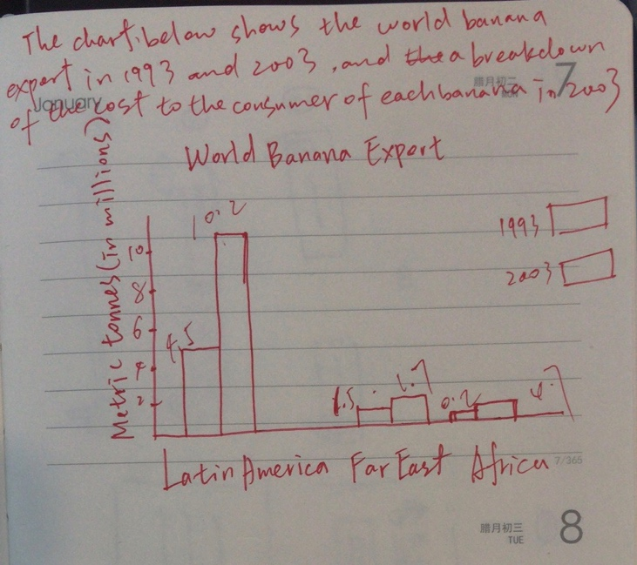

In this picture we can see the student has calculated the totals for each of the bars on the chart.

This is incorrect.

In the actual chart below we can see clearly the numbers on the Y axis. It provides us with whole numbers rising from 0 in units of 2 – 2, 4, 6, 8 and so on. It does not provide the mid point, nor decimal points between. Consequently, there is no way that we can know that the first Latin America bar is at 4.5 as the student suggests in the sketch above. Nor can we know that the second bar is 10.2. This is wrong and will not increase your band score.

The way we solve this is through vocabulary.
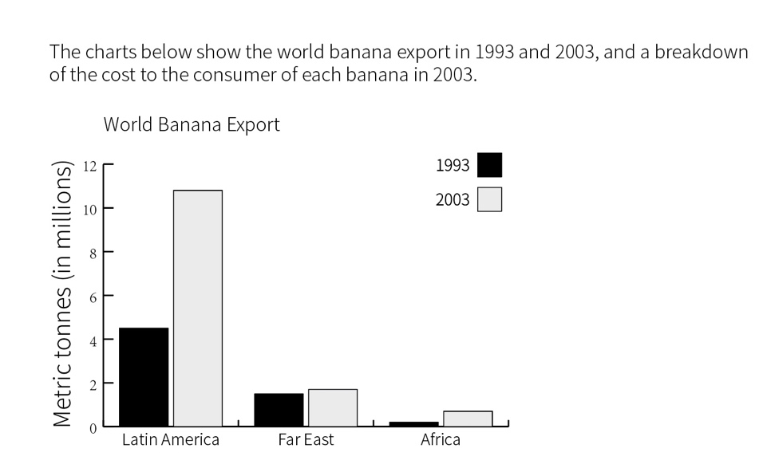
Thus, for Latin America in 1993 we would say exports were slightly over 4 million tonnes but rose sharply to well over 10 million tons in 2003. Exports in the Far East were more static with exports of around 2 million tonnes in 1993 and 2003. In Africa the exporting of bananas was negligible in 1993 with well under 1 million tonnes, however by 2003 around 1 million tonnes of the fruit was being exported.Task 1 key vocabulary.

Words/ Phrases of Approximation - Vocabulary:
» Approximately
» Nearly
» Roughly
» Almost
» About
» Around
» More or less
» Just over
» Just under
» Just around
» Just about
» Just below
» A little more than
» A little less than.

Fractions:
4% = A tiny fraction.
10% = one tenth.
20% = one fifth.
24% = Almost a quarter.
25% = Exactly a quarter.
26% = Roughly one quarter.
32% = Nearly one-third, nearly a third.
40%= two fifths
49% = Around a half, just under a half.
50% = Exactly a half, one half
51% = Just over a half.
73% = Nearly three quarters.
77% = Approximately three quarter, more than three-quarter.
79% = Well over three quarters.

Proportions:
2% = A tiny portion, a very small proportion.
4% = An insignificant minority, an insignificant proportion.
16% = A small minority, a small portion.
70% = A large proportion.
72% = A significant majority, A significant proportion.
89% = A very large proportion.

